**1. Problem Statement**

The tourism and travel industry has long been plagued by inefficiencies and limitations that hinder travelers from having a seamless experience. Some of the significant issues identified include:

* **Fragmented Information:** Travelers often struggle to find centralized platforms that provide comprehensive details about destinations, bookings, and activities.
* **Inefficient Processes:** Traditional booking methods involve multiple intermediaries, which can lead to delays, errors, and user dissatisfaction.
* **Limited Accessibility:** Existing platforms fail to cater to a wide audience, including those with specific needs, such as language preferences or accessibility requirements for individuals with disabilities.
* **Security Concerns:** Users are hesitant to share personal and financial information due to inadequate security measures on many platforms.

**Lack of Personalization:** Current systems lack the ability to provide tailored recommendations based on user preferences, behavior, and history

**1.3 Project Objectives**

The project is driven by a set of well-defined objectives aimed at solving the identified challenges and meeting user needs.

These objectives

**The main Goals of this project:**

1. **Enhancing Accessibility:**
   * Develop an inclusive platform that accommodates users from diverse linguistic and cultural backgrounds.
   * Implement accessibility features to ensure usability for individuals with disabilities.
2. **Streamlining Travel Processes:**
   * Consolidate all travel-related features, including booking, itinerary planning, and feedback collection, into a single, user-friendly interface.
3. **Improving User Experience:**
   * Design an intuitive interface that prioritizes ease of use and seamless navigation.
   * Offer personalized recommendations based on user preferences, history, and location.
4. **Ensuring Robust Security:**
   * Employ state-of-the-art encryption and authentication methods to safeguard user data and transactions.

**2 )Scope**

The scope of the project defines the features and functionalities that will be included in the initial version and outlines elements that are beyond the project's current capacity. This ensures clarity and focus throughout the development process.

**1 In-Scope Features**

* **Online Trip Booking and Management:** Users can search, select, and book trips directly through the platform.
* **Personalized User Profiles:** Individual profiles that store trip history, preferences, and feedback.
* **Interactive Features:** Q&A sections, user reviews, and community forums to foster engagement.
* **Integration with Navigation Tools:** Incorporation of Google Maps for location-based services and trip planning.
* **Multilingual Support:** Support for major languages to cater to a global audience.
* **Comprehensive Destination Content:** Detailed information about destinations, including cultural, historical, and recreational aspects.

**2 Out-of-Scope Features**

* **Offline Booking:** The system will not support offline booking mechanisms in the initial release.
* **Advanced Payment Integrations:** Limited to basic payment processing; advanced options will be added in future iterations.
* **Real-Time Flight Tracking:** Excluded for the initial version but considered for future development.
* **3 ) Functional Requirements**
* Allows admins and travelers to **log in and out**.
* Allows visitors as a guest to see the entire site and nomads without being **booked** without having logged in.
* admins and travelers are allowed to book the trip, **provided that the age is over 18 years.**
* admins and travelers are allowed to edit or delete comments within the site.
* Allows admins and travelers to see responses to comments on the site.
* Allows admins and travelers to respond to comments on the site.
* **4) Non-functional requirements:**
* **Usability:** 
  + The user-interface shall be user friendly.
  + The traveler and Admin page address should reflect the name you're logged in to.
* **Reliability:** 
  + Components of the project code will be tested alongside the implementation phase to ensure that they are functional.
  + Final, integrated project Code will be tested in enough time.
* **Performance:** 
  + Doing the operations must be smooth without graphical lagging.
  + Real-time response to requests.
* **Implementation:** 
  + Project will be implemented in php.
  + All project graphical user interfaces will be created using a HTML, CSS and JavaScript.
* **Scalability:** that is for any future enhancements and additions.
* **Availability:** 24/7 to arrive and book trips at all times.

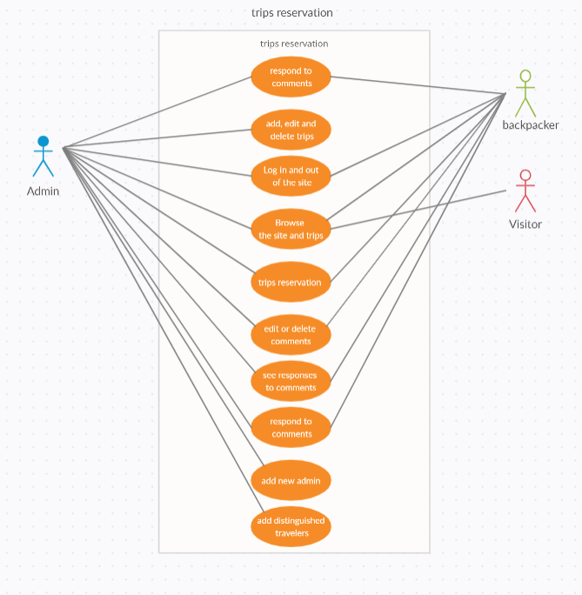

**- System Use Case**